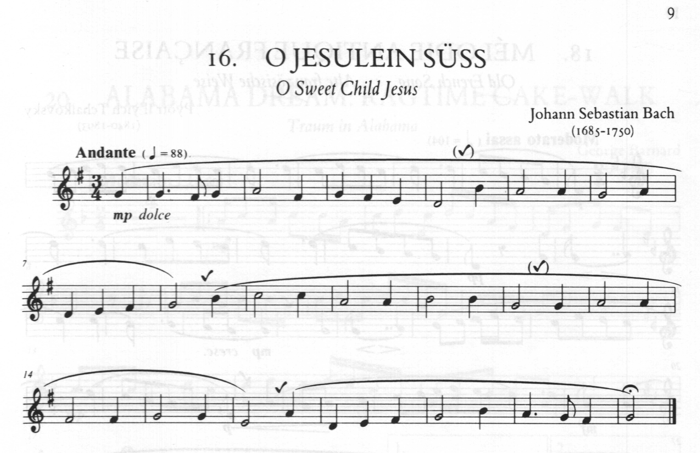
Teaching Notes :- 3/ 4 time starts on beat 3. Key of G (play f sharp {2nd valve} all the way through)
The long curved line is not a slur but a phrase mark but play with a soft tongue action (dooo)
Learn the dotted rhythm at the start and the end carefully ,think 12 and 3 breath at the ticks

